**ARYAMAN MISHRA**

**19BCE1027**

1)

A nationalized bank is offering loans to buy home and vehicles. Devise a program that creates an abstract class named Loansand subclasses to display different types of loans and cost per month ( home, car, and so on..) Use constructors in each of the classes with appropriate arguments. Include get and set methods and an abstract method calculateLoan(). Prompt the user for the type to be displayed, and then create the appropriate object. Also create an interface with one method printDetails() that you use with subclasses.

Save the Loan.java, Home.java, Car.java and Print.java in MyBank package and the testing program in UseLoan package.

package MyBank;

abstract class Loan {

public abstract void homeloan();

public abstract void calculateLoan();

}

interface Print{

void printDetails();

}

// Subclass (inherit from Loan)

public class Home extends Loan implements Print{

double loanh;

int timeh,interesth,moneyh;

public Home(int a,int b)

{

loanh=0.00d;

moneyh=a;

interesth=15;

timeh=b;

}

public void homeloan()

{

// The body of homeloan() is provided here

System.out.println("This Loan applies to any place assets in your posession.");

System.out.println("Tenure ranges from 1 to 30 years.Interest is 15%.");

}

public void calculateLoan()

{

loanh=moneyh+timeh*(interesth*moneyh/100);

}

public void printDetails()

{

System.out.println("Home Loan="+loanh);

}

}

package MyBank1;

abstract class Loan {

public abstract void carloan();

public abstract void calculateLoan();

}

interface Print{

void printDetails();

}

// Subclass (inherit from Loan) add in loan public abstract void carloan();

class Car extends Loan implements Printable {

double loanc;

int timec,interestc,moneyc;

Car(int a,int b)

{

loanc=0.00d;

moneyc=a;

interestc=8;

timec=b;

}

public void carloan() {

System.out.println("This Loan applies to any 4 wheeled vehicle in your posession.");

System.out.println("Tenure ranges from 1 to 10 years.Interest is 8%.");

}

public void calculateLoan()

{

loanc=moneyc+timec*(interestc*moneyc/100);

}

public void printDetails()

{

System.out.println("Car Loan="+loanc);

}

}

package UseLoan;

import MyBank.*;

import java.util.*;

public class LoanTest

{

public static void main(String args[])

{

Scanner sc=new Scanner(System.in);

System.out.println("Enter Loan Amount and Time needed.");

int l=sc.nextInt();

int t=sc.nextInt();

Home ob=new Home(l,t);

ob.homeloan();

ob.calculateLoan();

ob.printDetails();

}

}

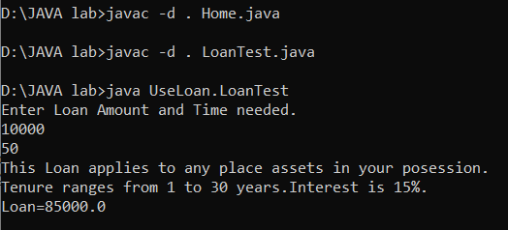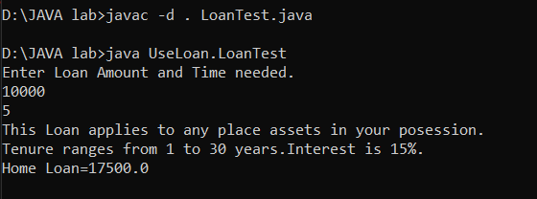

2)

Create a class named TaxPayer. Data fields for TaxPayer include Social Security number (type long) and yearly gross income. Methods include a constructor that requires values for both data fields and two get methods that returns each of the data field values. The gross income should be in the range from $10000 to $100,000.

Write a JAVA program named UseTaxPayer that declares an array of 10 Taxpayer objects and display the 10 Taxpayer objects.

import java.util.*;

class TaxPayer

{

int income;

long ssn;

TaxPayer()

{

ssn=0L;

income=0;

}

TaxPayer(long a,int b)

{

ssn=a;

income=b;

}

long getssn()

{

Scanner sc=new Scanner(System.in);

System.out.println("Enter Social Security Number.");

long x=sc.nextLong();

return x;

}

int getincome()

{

Scanner sc=new Scanner(System.in);

System.out.println("Enter Yearly gross income in Dollars.");

int x=sc.nextInt(),amt;

if(x>=10000 && x<=100000)

amt=x;

else

{

System.out.println("The gross income should be in the range from Rs.10000 to Rs.100,000.Try Again.");

amt=getincome();

}

return amt;

}

}

class UseTaxPayer

{

public static void main(String[] args)

{

Scanner sc=new Scanner(System.in);

System.out.println("Enter number of Taxpayer.E.g. 10,5");

int n=sc.nextInt();

long x;

int y;

TaxPayer[] a=new TaxPayer[n];

for(int i=0; i< n;i++)

a[i] = new TaxPayer();

for(int i=0;i<n;i++)

{

x=a[i].getssn();

y=a[i].getincome();

a[i]=new TaxPayer(x,y);

}

for(int i=0;i<n;i++)

{

System.out.println("Social Security Number="+a[i].ssn);

System.out.println("Yearly Gross Income="+a[i].income);

}

}

}

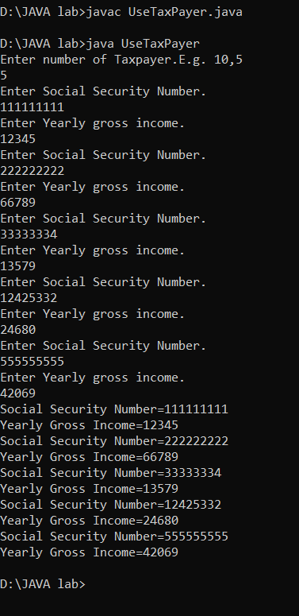

3)

Star Insurance Company is offering different policies. You are asked to write a program that uses an abstract class named Insurance and Health and Life subclasses to display different types of insurance policies and the cost per month. Use constructors in each class, with appropriate arguments. Include get and set methods, and an abstract method calculatePremium(). Prompt the user for the type to be displayed, and then create the appropriate object. Also create an interface for a print() method and use this interface with both subclasses.

Save the Insurance.java, Health.java, Life.java and Print.java in StarInsurance package and the testing program in defaultpackage.

package StarInsurance;

// Abstract class

abstract class Insurance {

// Abstract method (does not have a body)

public abstract void calculatePremium();

}

interface Print

{

void printable();

}

// Subclass

class Health extends Insurance implements Print {

int cost,time;

int p;

Health(int a,int b)

{

cost=a;

time=b;

}

public void calculatePremium() {

System.out.println("You have chosen Health Insurance.");

p=cost*time*2;

}

public void printable()

{

System.out.println("Premium="+p);

}

}

// Subclass

class Life extends Insurance implements Print {

int cost,time;

int p;

Life(int a,int b)

{

cost=a;

time=b;

}

public void calculatePremium() {

System.out.println("You have chosen Life Insurance.");

p=cost*time;

}

public void printable()

{

System.out.println("Premium="+p);

}

}

package defaultpackage;

import StarInsurance.*;

import java.util.*;

public class InsuranceOfficer

{

public static void main(String args[])

{

Scanner sc=new Scanner(System.in);

System.out.println("Enter Amount and Time for Insurance.");

int l=sc.nextInt();

int t=sc.nextInt();

//System.out.println("Enter 1 for Life Insurance,2 for Health Insurance.");

//int choice=sc.nextInt();

//if(choice==1)

//{

Life ob1=new Life(l,t);

ob1.calculatePremium();

ob1.printable();

//}

//else

//{

//Health ob2=new Health(l,t);

//ob2.calculatePremium();

//ob2.printable();

}

}

